# **UFCF85-30-3 Enterprise System Development**

# **Sprint Review Form**

| Group: | 18 |
| --- | --- |
| Sprint: | 2 |
| Members: | Benedict Ramage-Mangles, Ross Williams, Arjun Binning, Michael Duncan, Matthew Hill |

<<Burn-down Chart>>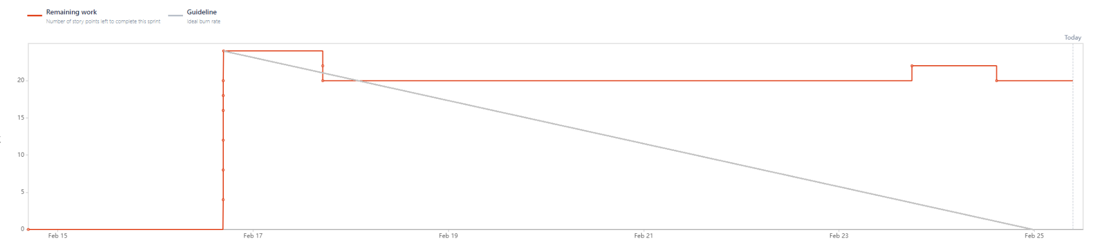

<<Backlog list>>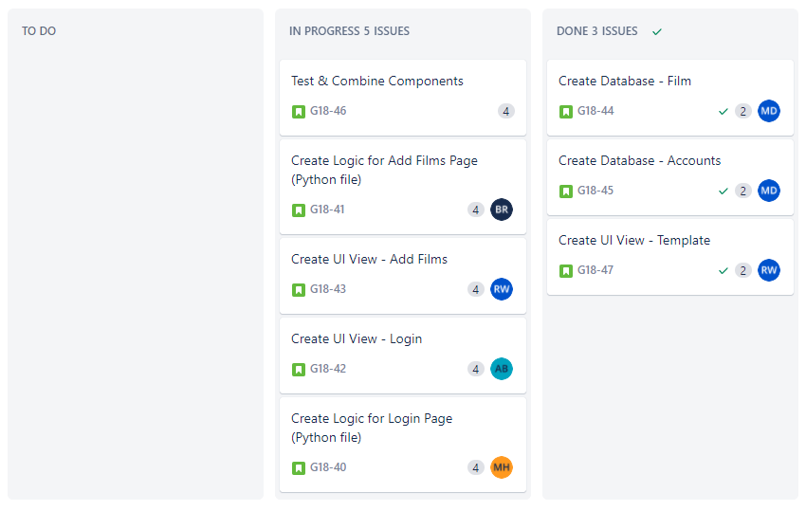

Sprint Backlog:

Product Backlog:

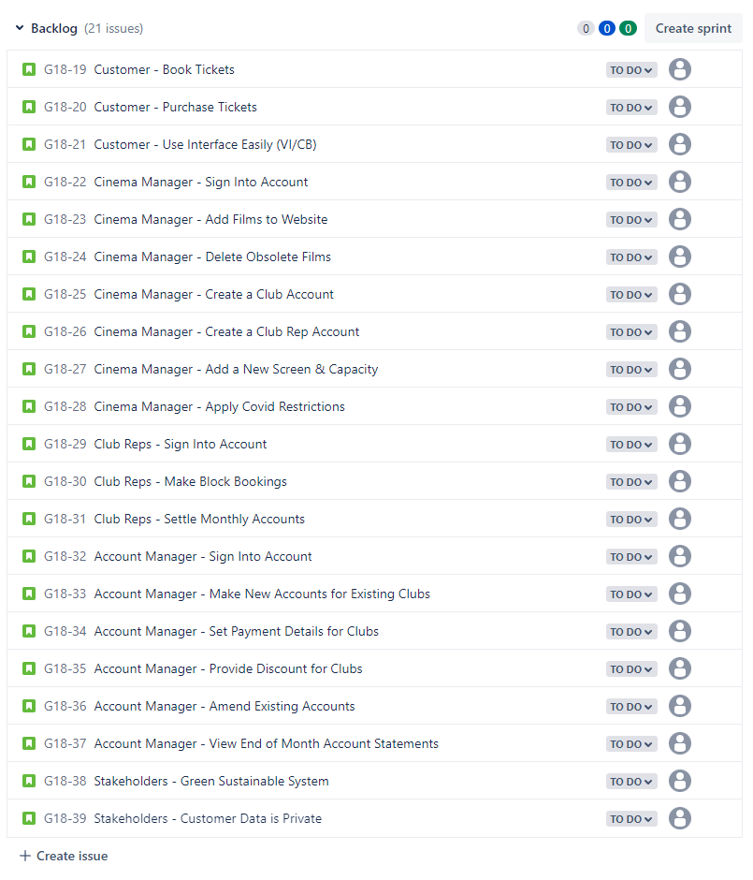

<<Communication Issues>>

While there was no meeting at the practical this week (22/2), the whole team has been communicating well, with us setting up a regular meeting on Wednesdays, which we have all attended both weeks of this sprint.

<<Reflections>>

| Task | Person | What Went Well | Needs Work | Comments |
| --- | --- | --- | --- | --- |
| Creating Database Models for Account & Film | Michael Duncan | Both Models have been created successfully and have been pushed onto the system. | Requires integration with other components to give them full functionality. | I attempted a similar setup in the practical last week and struggled with combining relational models with forms on the templates. This was especially difficult when attempting to create multiple forms on one page. I will have to look into this further in future sprints. |
| Create UI View for the Login Page | Arjun Binning | Solid progress has been made in learning the skills required to do this task, and briefly using those skills accomplish it | Requires the use of a created template so the page matches with other created pages | Initially I wasn’t too sure how I was gonna tackle this, however after spending some time researching and reading, I became familiar with what I needed to do and set out to work on it. Only a few touch ups and theme integration is required. |
| Create UI Template | Ross Williams | Base template for the UI has been made. Provides template so other UI features can be created. | Template can be improved when other features are created. | Virtual environment was hard to configure. A lot of time was spent learning various elements of Django and Git. |
|  |  |  |  |  |

<<Relevant Links>>

github.com/bean64/Group-18-ESD-2022

https://discord.gg/zwjTNUzEhM